Week-6 ASE
Step 1: Check Docker Desktop
First, open Docker Desktop on your computer.
Wait until Docker Desktop shows that it is running.
Then open PowerShell.
Run:
docker --version
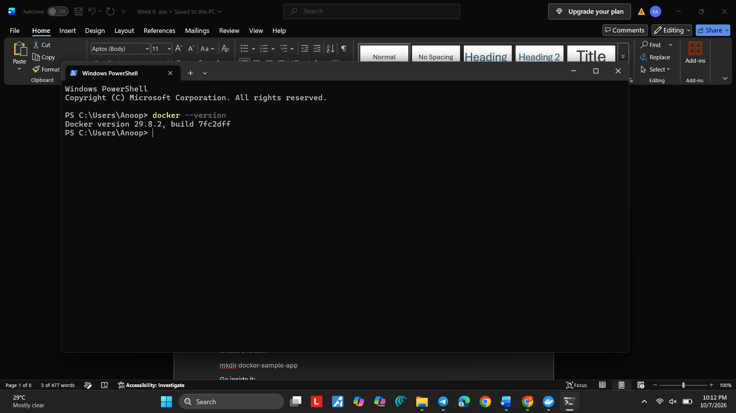
Step 2: Create a project folder
In PowerShell, go to a location where you want to create the project.
For example:
cd D:\
Create a folder:
mkdir docker-sample-app
Go inside it:
cd docker-sample-app
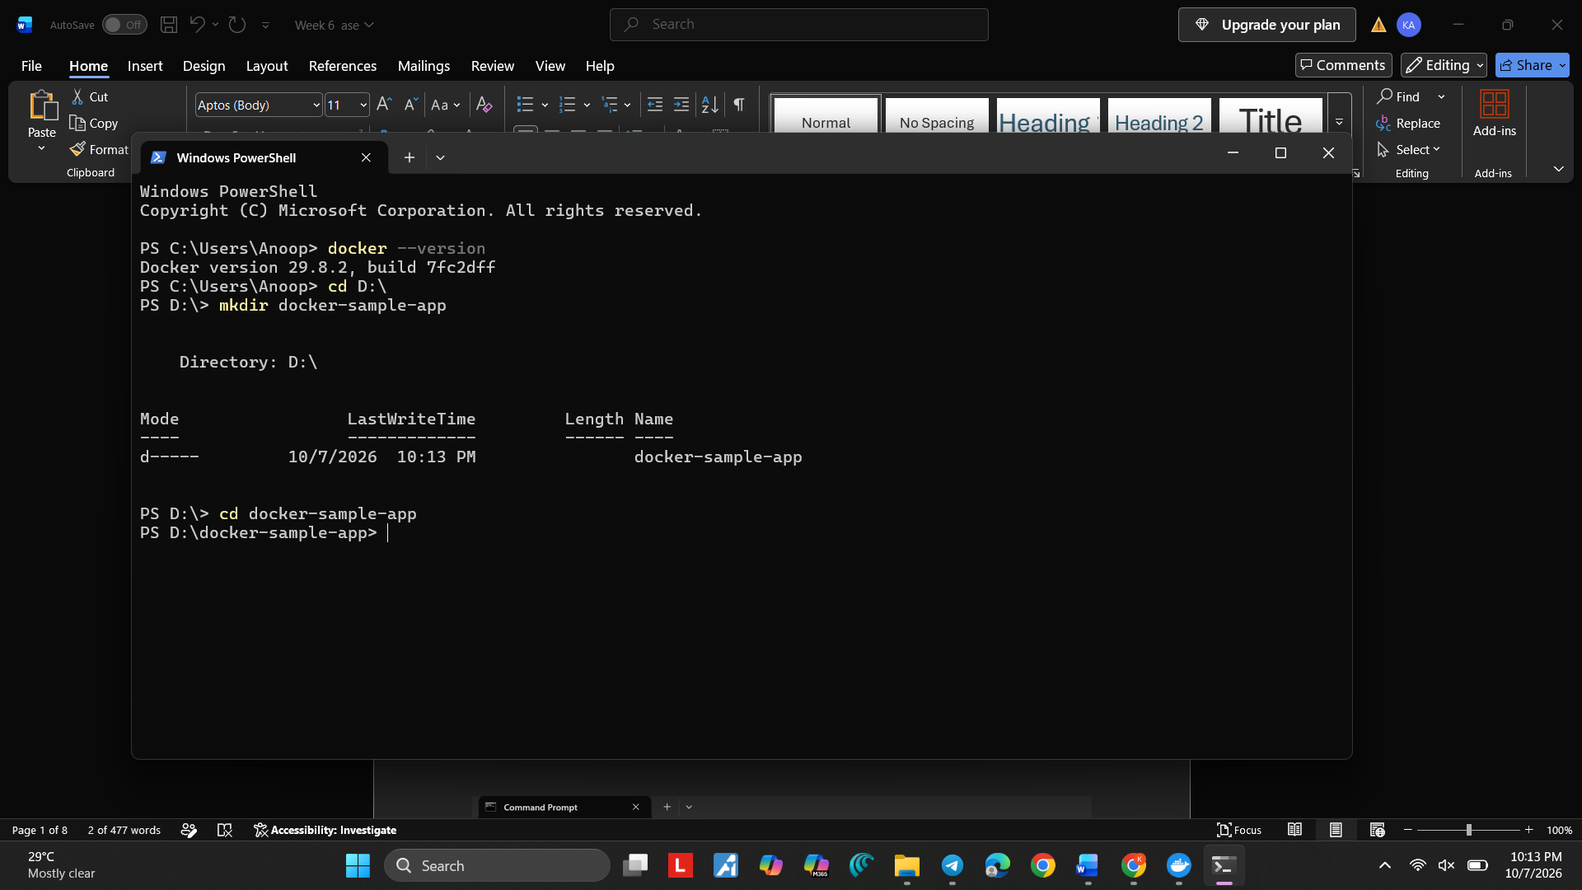
Step 3: Create index.html
Make sure your prompt looks like:
C:\Users\CHERISHMA.SANA\docker-sample-app>
Now type:
notepad index.html
Press Enter.
Notepad will open and may ask:
Do you want to create a new file?
Click Yes.
Paste this exactly:
<!DOCTYPE html>
<html>
<head>
<title>Docker Sample Application</title>
</head>
<body>
<h1>Hello from Docker!</h1>
<p>My first application is running inside a Docker container.</p>
</body>
</html>
Then:
File → Save
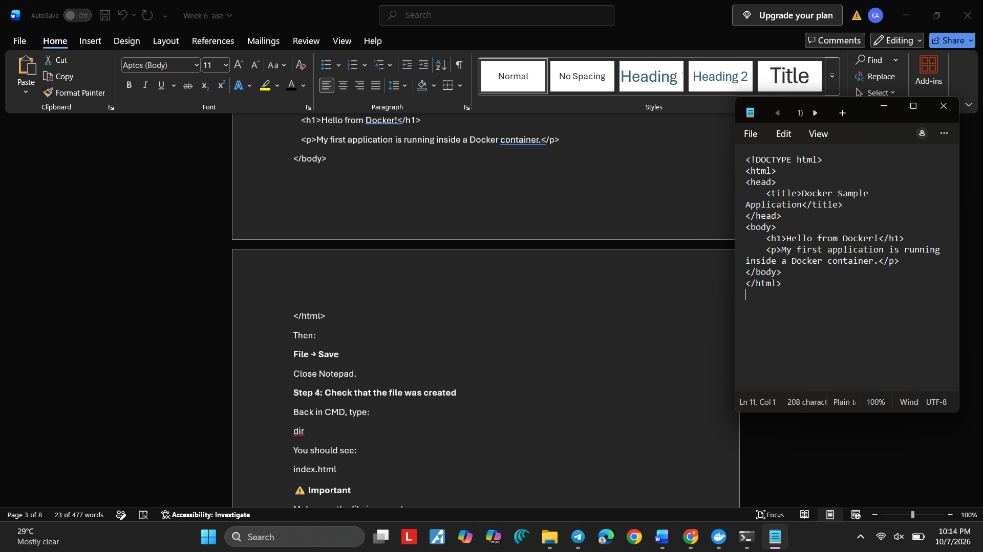
Close Notepad.
Step 4: Check that the file was created
Back in CMD, type:
dir
You should see:
index.html
⚠️ Important
Make sure the file is named:
index.html
not
index.html.txt
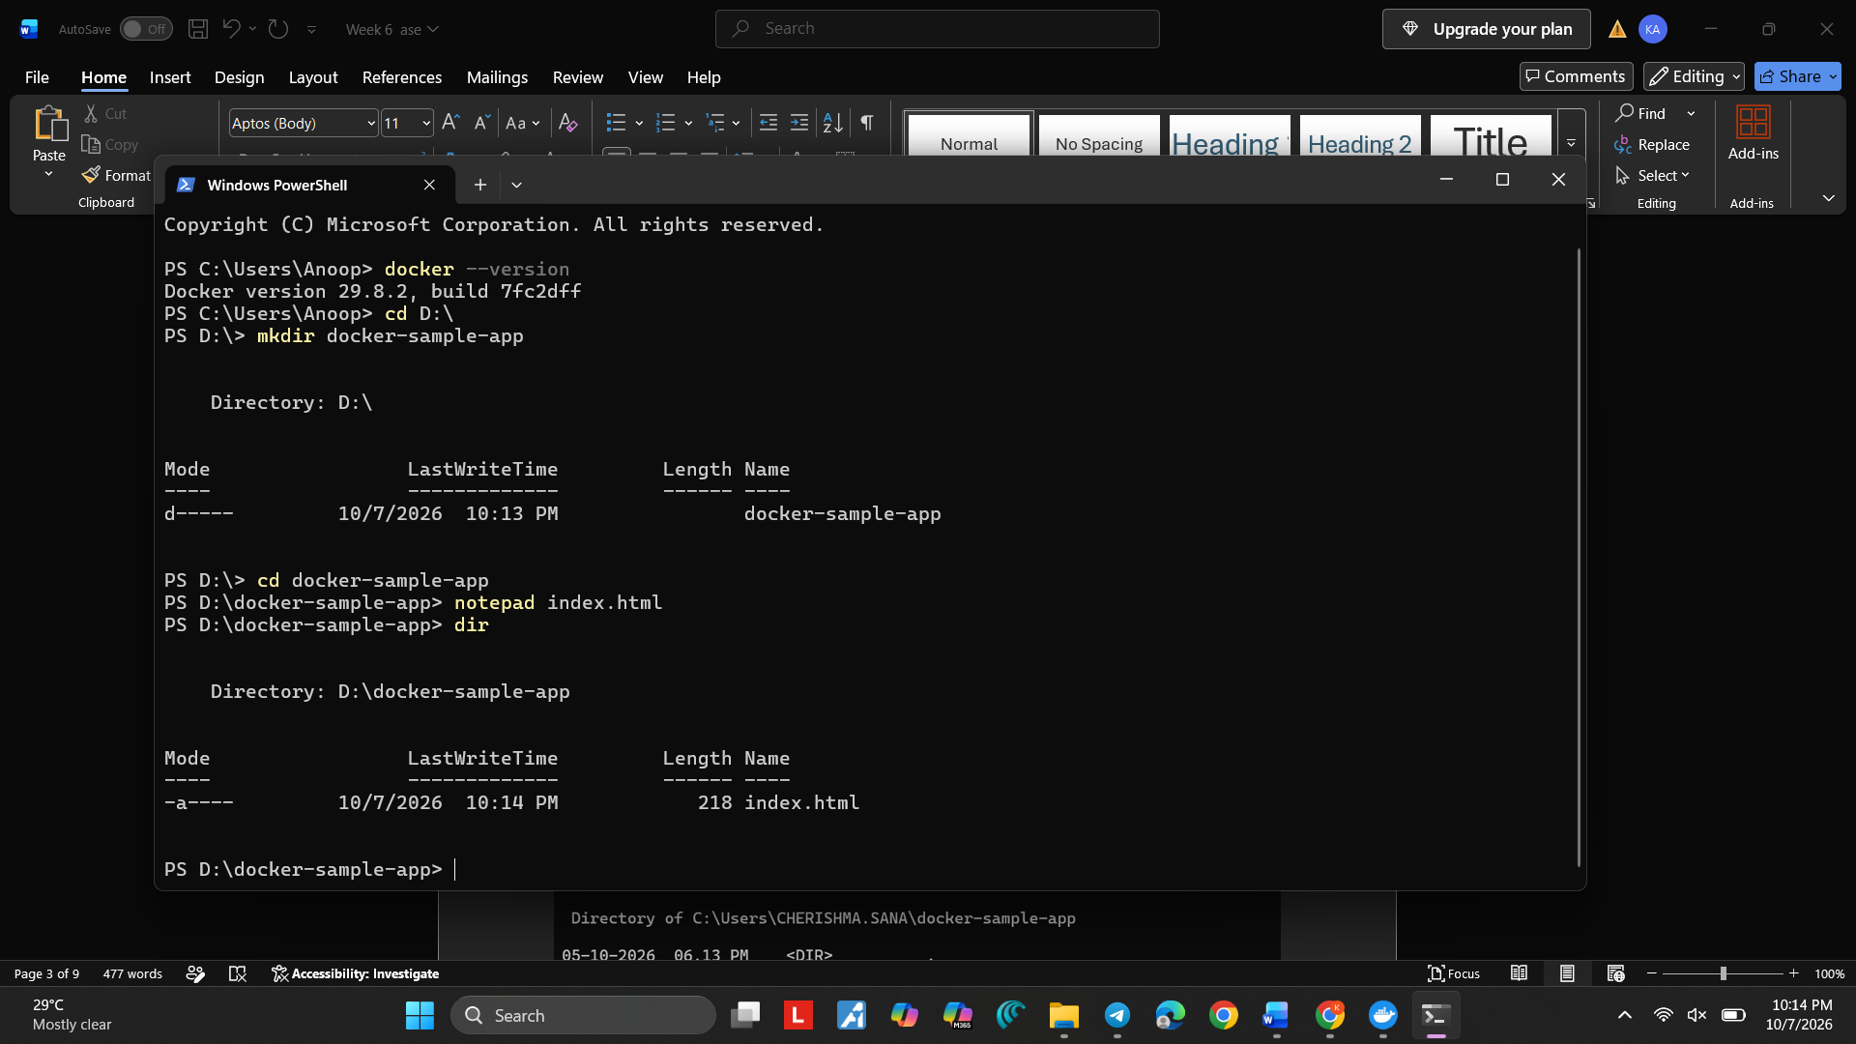
Step 5: Create the Dockerfile
Type:
notepad Dockerfile
Press Enter.
If Notepad asks whether you want to create a new file, click Yes.
Step 6: Paste this Dockerfile
Copy and paste exactly:
FROM nginx:latest

COPY index.html /usr/share/nginx/html/index.html

EXPOSE 80
Then:
File → Save
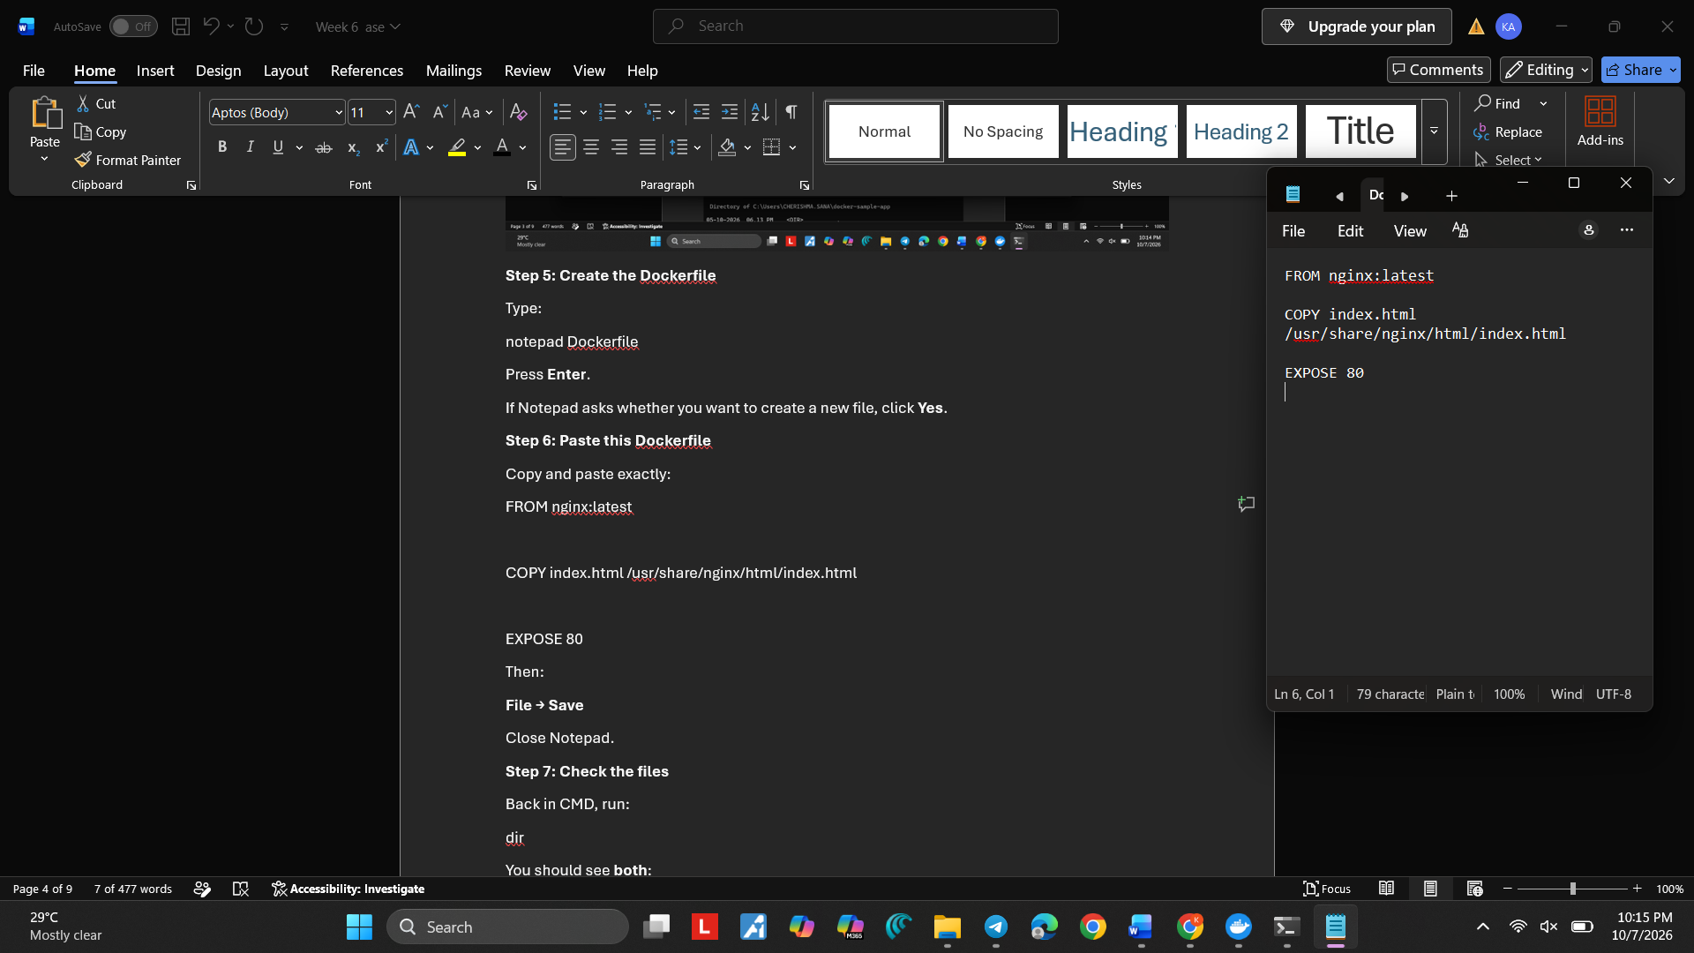
Close Notepad.
Step 7: Check the files
Back in CMD, run:
dir
You should see both:
Dockerfile
index.html
Your folder should now contain:
docker-sample-app
│
├── Dockerfile
└── index.html
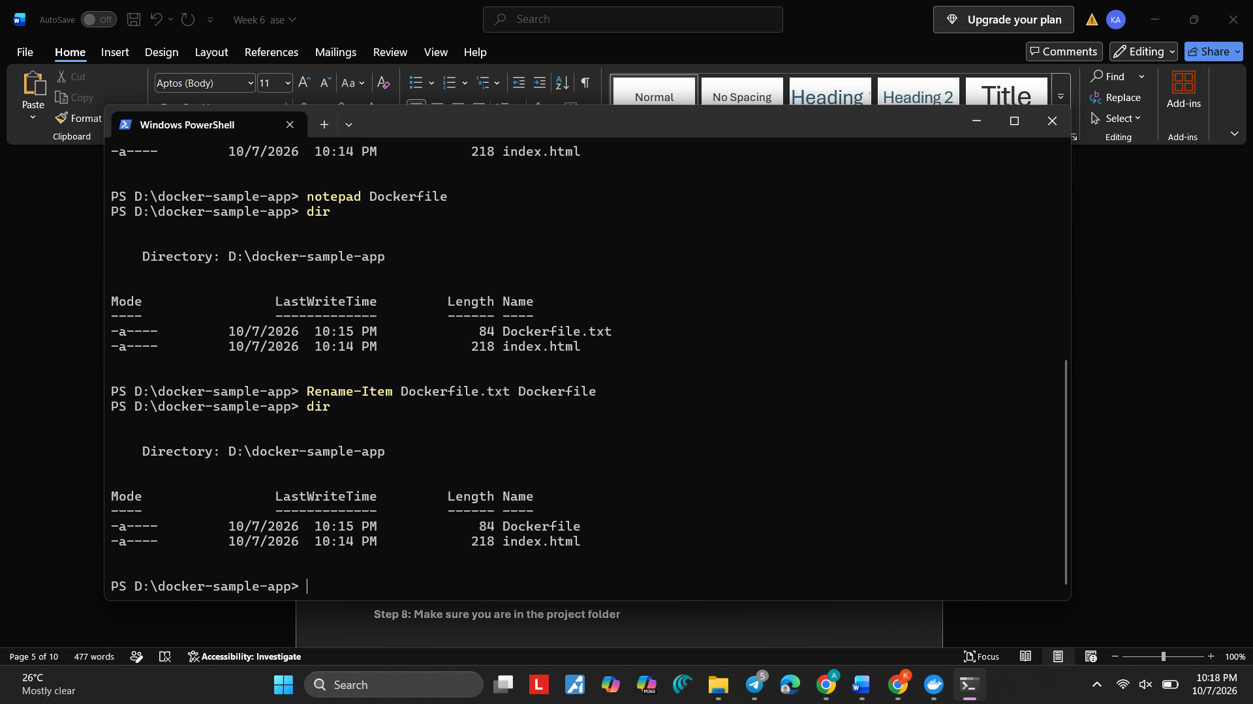
Step 8: Make sure you are in the project folder
Your CMD should show:
C:\Users\CHERISHMA.SANA\docker-sample-app>
If yes, run:
docker build -t docker-sample-app .
⚠️ Important: Keep the . at the end.
Step 9: Wait for the build to finish
You should see Docker doing things like:
[+] Building ...
[+] ...
At the end, you should see something similar to:
Successfully tagged docker-sample-app:latest
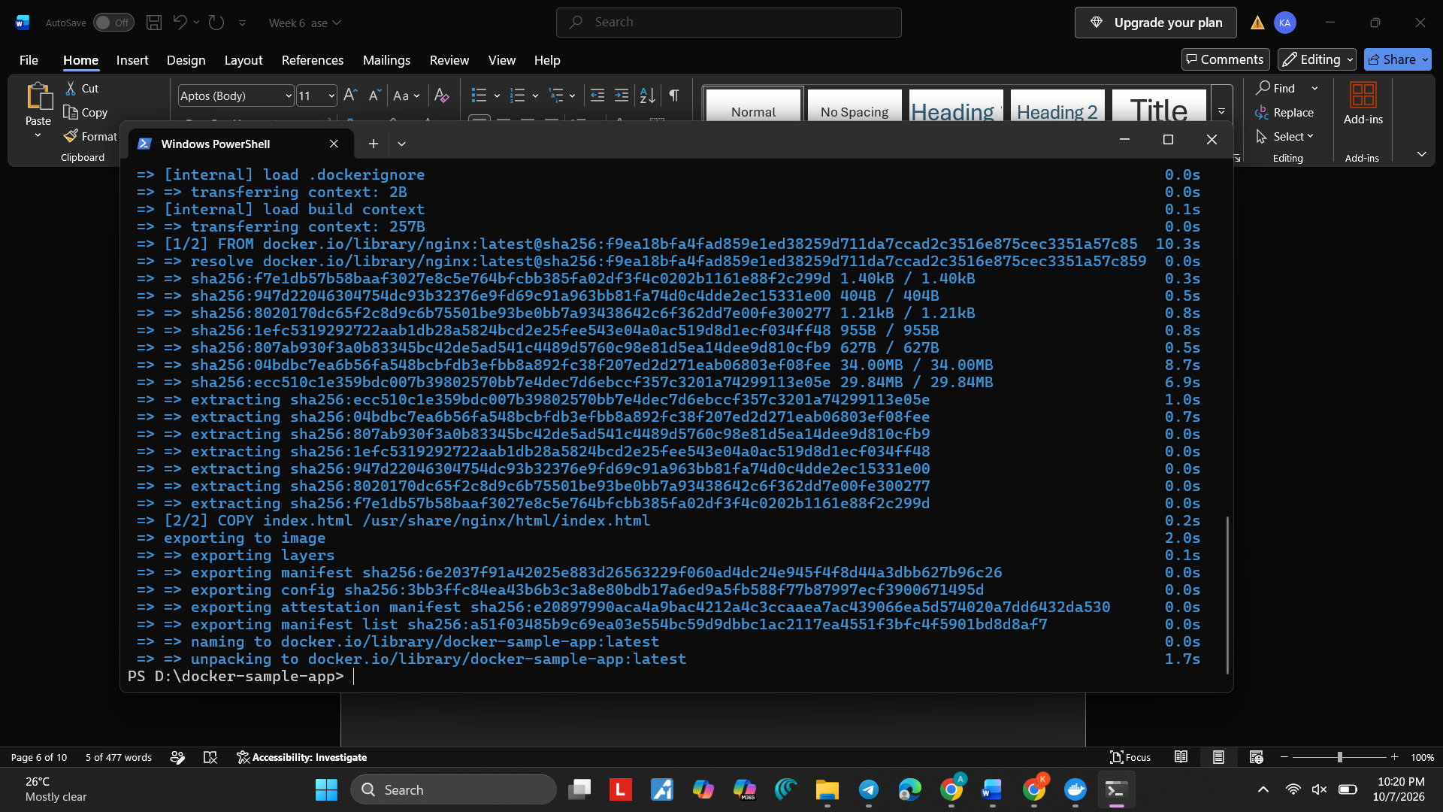
Step 10:Then run:
docker images
You should see:
docker-sample-app latest
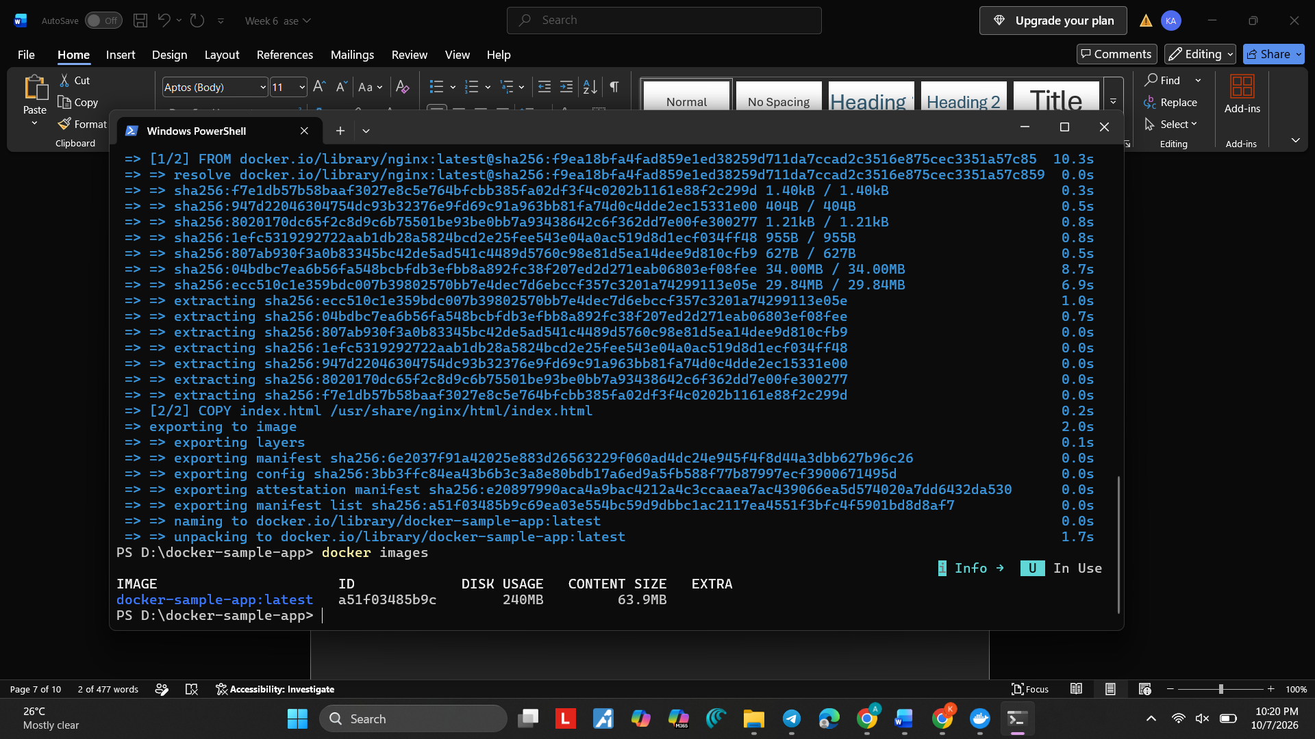
Step 11: Run the container
Run this exactly:
docker run -d -p 8080:80 --name docker-sample-container docker-sample-app
If successful, Docker will display a long container ID, for example:
a7c8d9e0f1...
That means the container has started.
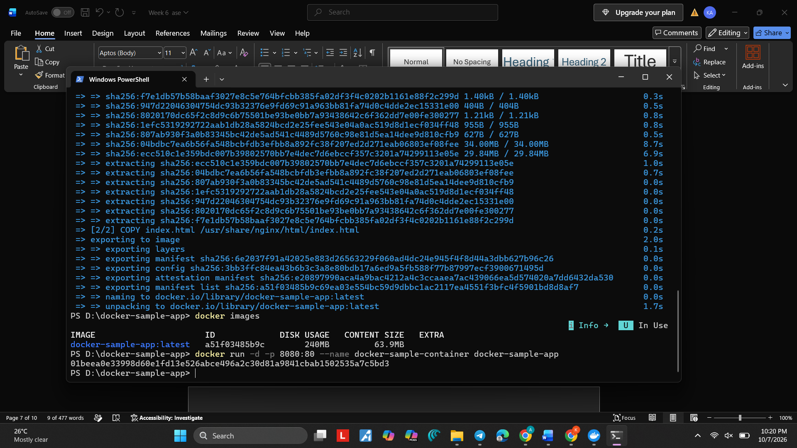
Step 12: Check that the container is running
Run:
docker ps
You should see something similar to:
CONTAINER ID IMAGE STATUS PORTS
xxxxxxxx docker-sample-app Up ... 0.0.0.0:8080->80/tcp
The important things are:
IMAGE: docker-sample-app
STATUS: Up
PORTS: 8080->80
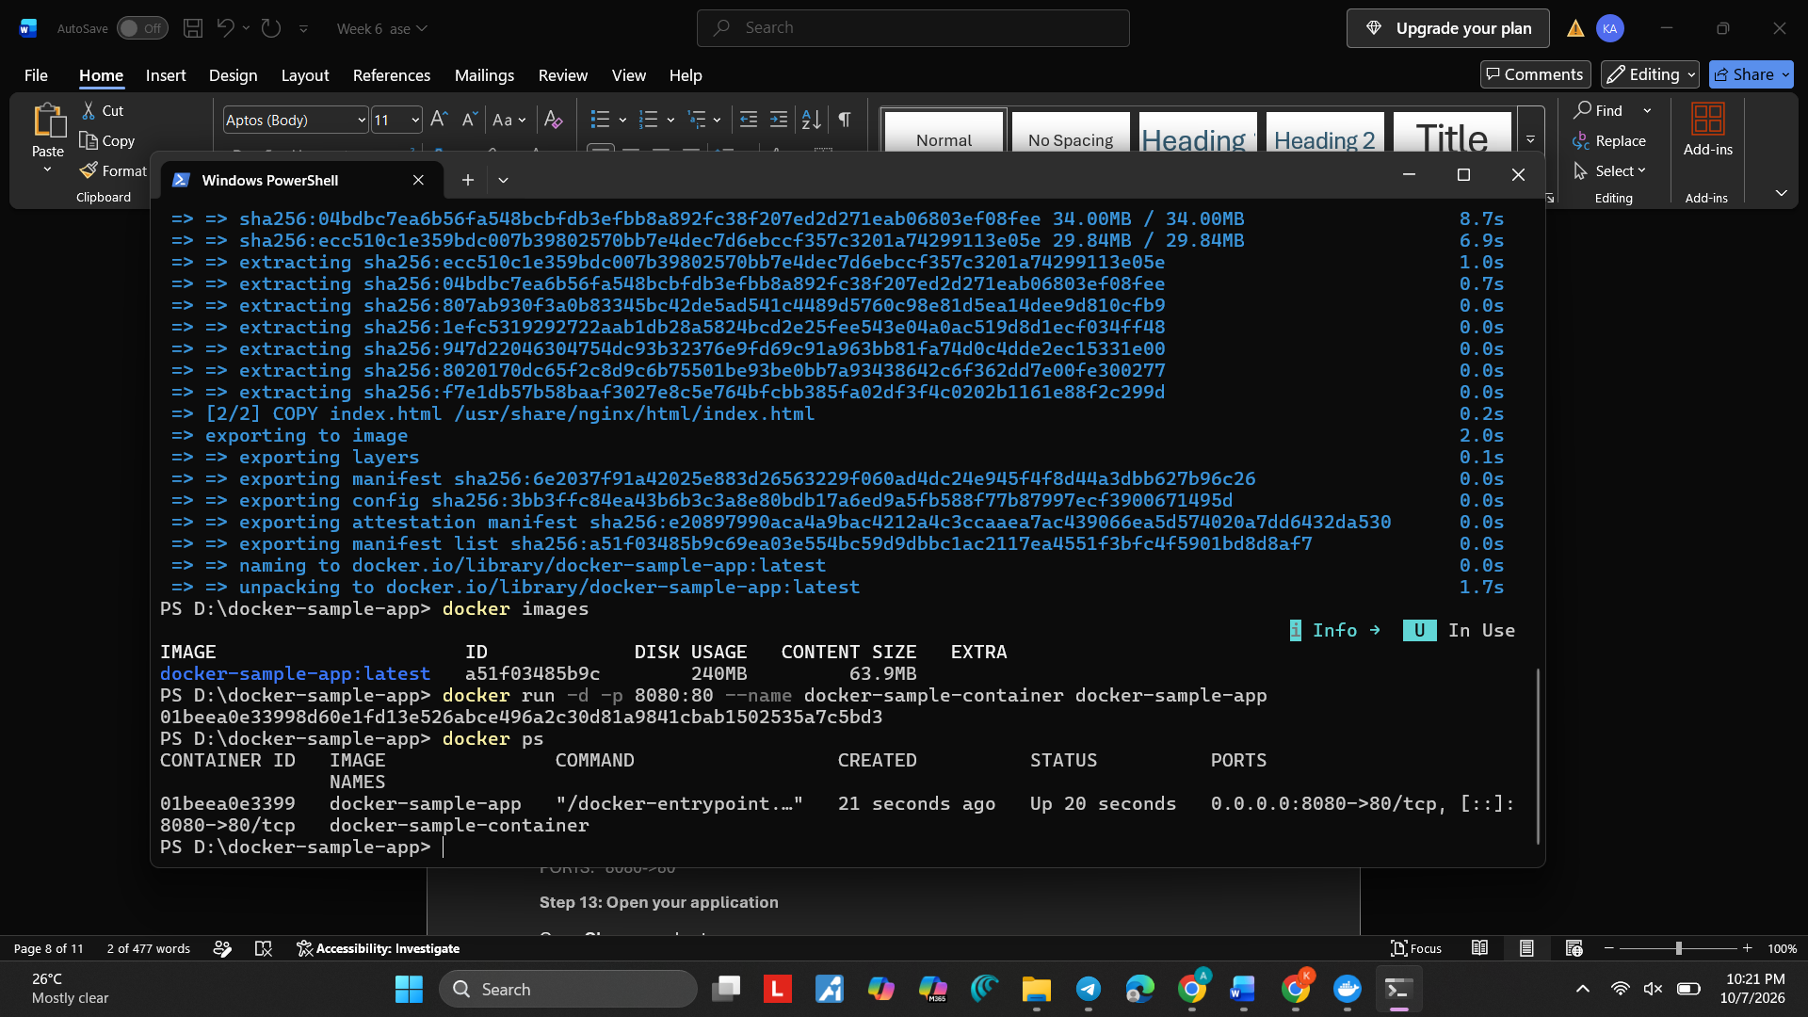
Step 13: Open your application
Open Chrome and enter:
http://localhost:8080
You should see:
Hello from Docker!
and:
My first application is running inside a Docker container.
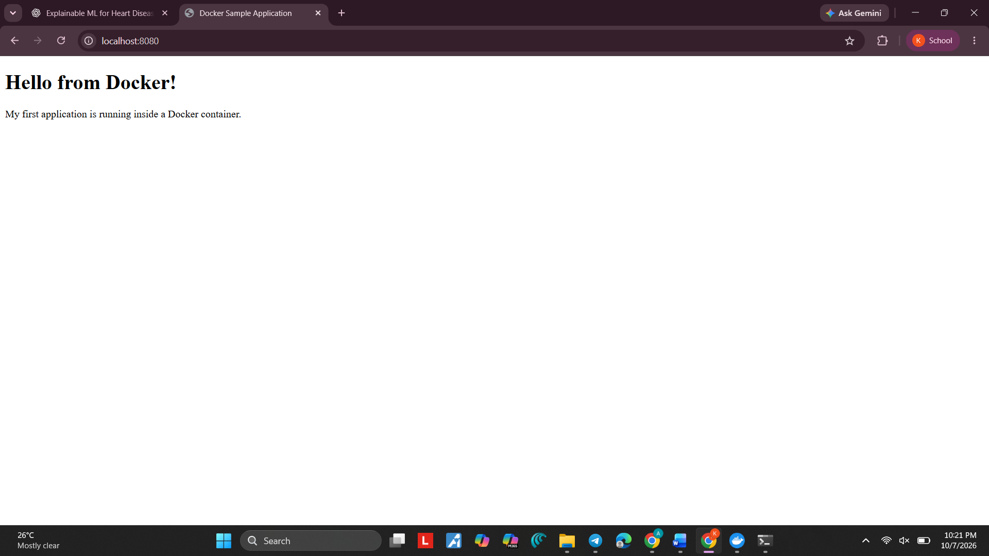
Step 14: Check the container
Go back to CMD and run:
docker ps
You should see your container:
docker-sample-container
with status:
Up ...
Step 15: Check the container logs
Run:
docker logs docker-sample-container
This displays the NGINX container logs.
Step 16: Stop the container
After you have verified the webpage, run:
docker stop docker-sample-container
You should get:
docker-sample-container
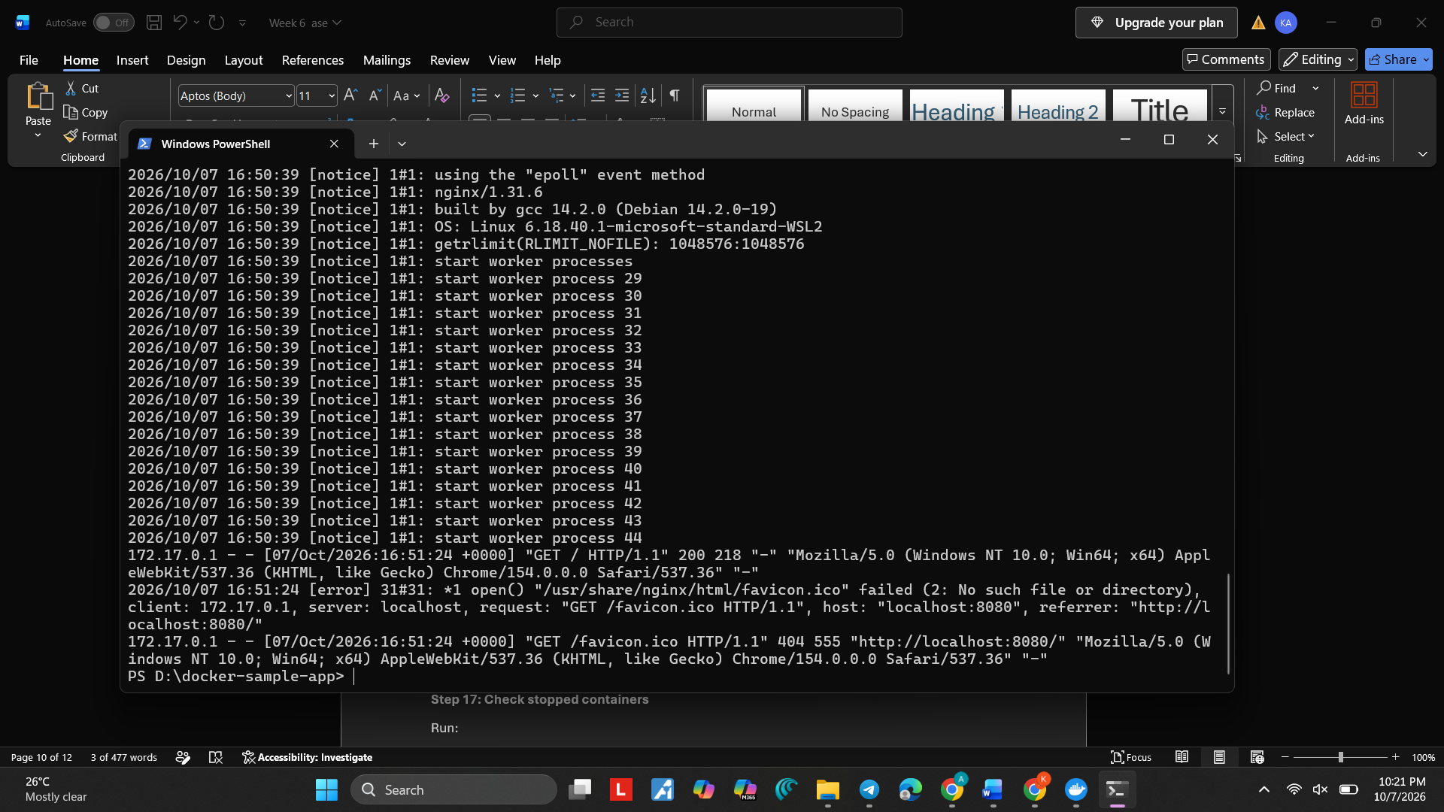
Step 17: Check stopped containers
Run:
docker ps -a
You should see:
docker-sample-container
with a status similar to:
Exited
